Sermon Notes: Pressing on in Surpassing Greatness
Philippians 3:12-16

Christians aren’t perfect, just f !

John 14:6 “Jesus answered, “I am the way and the truth and the life. No one comes to the Father except through me.”
3:12 – Paul uses “not” to refer to the preceding verses??

v 8 “knowledge of Christ”, v 9 “righteousness by faith”
v 10 “resurrection power, sharing in Christ’s suffering and
death”; v 11 “future resurrection from the dead”

We don’t go to heaven based on our own p !

“Perfect” doesn’t have to mean sinlessness…it is translated

from the same Greek word translated M

Press On = to C or hunt down.

“For which” speaks of P .

Philippians 3:7-11 I consider EVERYTHING a l compared to the surpassing greatness of knowing Christ Jesus my Lord…that I may gain Christ…I want to know Christ and the power of His resurrection…

Psalm 139 makes clear that you were on God’s mind while you were in your mother’s womb!

Is God more than an acquaintance to you?

Verse 13: F what is behind! S
toward what is ahead!

Verse 14: P on toward the goal!

Satan is the a of the brothers! How do you tell the difference between his accusing attacks and the conviction of the Holy Spirit? The conviction of the Holy

Spirit is ALWAYS R ! God forgives and forgets!
Jesus is holding resurrection power in reserve for YOU!

Welcome
to
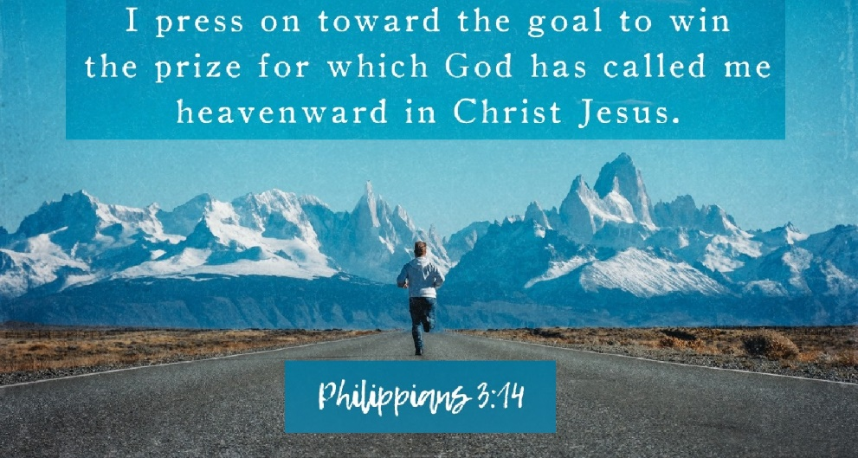
East Lake Road Alliance Church

4500 East Lake Road
Erie, Pennsylvania 16511
814-898-2771

Interim Pastor: Clyde Davis
Pastor Clyde’s cell number: 814-397-6229
Clyde.L.Davis@gmail.com

Connect with us:
hello@elrac.info elrac.info youtube.elrac.info facebook
Church e-mail: hello@elrac.info

Morning Worship Service
October 8, 2023 at 11:00

Call to Worship: Psalm 18:1-3a
“I love you, O Lord, my strength.
The Lord is my rock, my fortress and my deliverer; my God is my rock, in whom I take refuge. He is my shield and the horn of my salvation, my stronghold. I call to the Lord,
who is worthy of praise.”

Songs of worship: Ancient of Days
Wonderful Merciful Savior
When I Look Into Your Holiness

Opening prayer

Announcements and Worship Through Giving

Songs of worship: Build My Life
At the Cross (Love Ran Red)

Intercessory Prayer

Message by Pastor Clyde:
Pressing On in Surpassing Greatness

Closing Song: Softly and Tenderly

Benediction

MINISTRY OPPORTUNITY: Our shut-ins would love a visit from YOU. Talk to a Deacon/Deaconess if interested.
This Week in the Church:
Tuesday, Noon – Young at Heart meet at Dutch Village
Restaurant, Clymer, NY for lunch – Please sign up
Wednesday, 6:00 PM New Time – Adult Prayer meeting,
Youth Group and Kids for Christ
Thursday, 6:30 PM – Board of Ministries meeting
6:30 PM - Pickleball…all are invited
Sunday, 9:45 AM – Sunday School for all ages
11:00 AM – Morning Worship Service
Saturday, October 21st, 11 AM – Ladies’ Luncheon at
Ricardo’s Restaurant

Greeters: Ron and Gerri Thompson
Ushers: Chuck DeAngelo, Dave DeAngelo

Pray for: Our Elders as they seek the leading of the Holy Spirit in the calling of a new lead pastor for ELRAC.
- Paul Vogel-full healing from sinus surgery.
- Tammy Wright and Jeremy Biddle in this time of loss.
- Pray for Paul Hollman, who was treated recently at Cleveland Clinic. He is on meds for blood clots/lungs.

Missions Project Goal = $3,000.00
Over $1,200 has been received toward this project! Let’s assist Joel and Sally in providing food packages for refugees in their area.

We are in need of a new church custodian. If you are interested, please see Pastor Clyde, John Baker or one of our trustees.

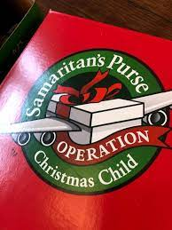
Children around the world need to hear that Jesus loves them. Samaritan’s Purse Shoebox gift boxes help to express that in a tangible way with gifts and a copy of God’s Word. Let’s join together in this project. Suggestion lists are available in the Foyer.

